**Question-1:- Store Sales Data:-**

Updated the column Headers:-

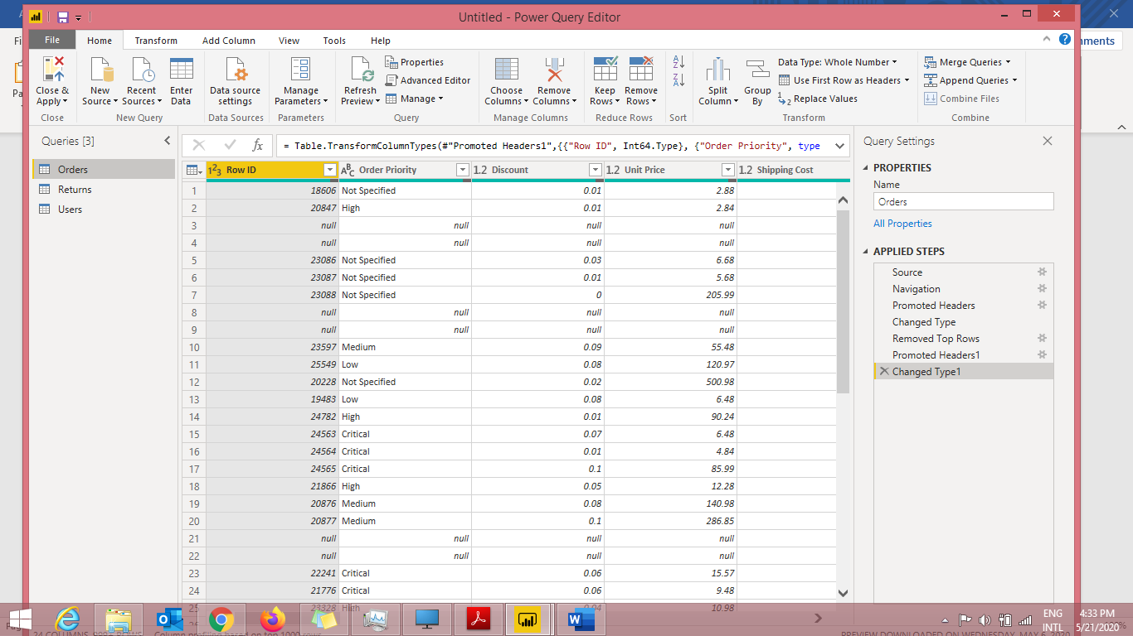

Removed Blank rows:-

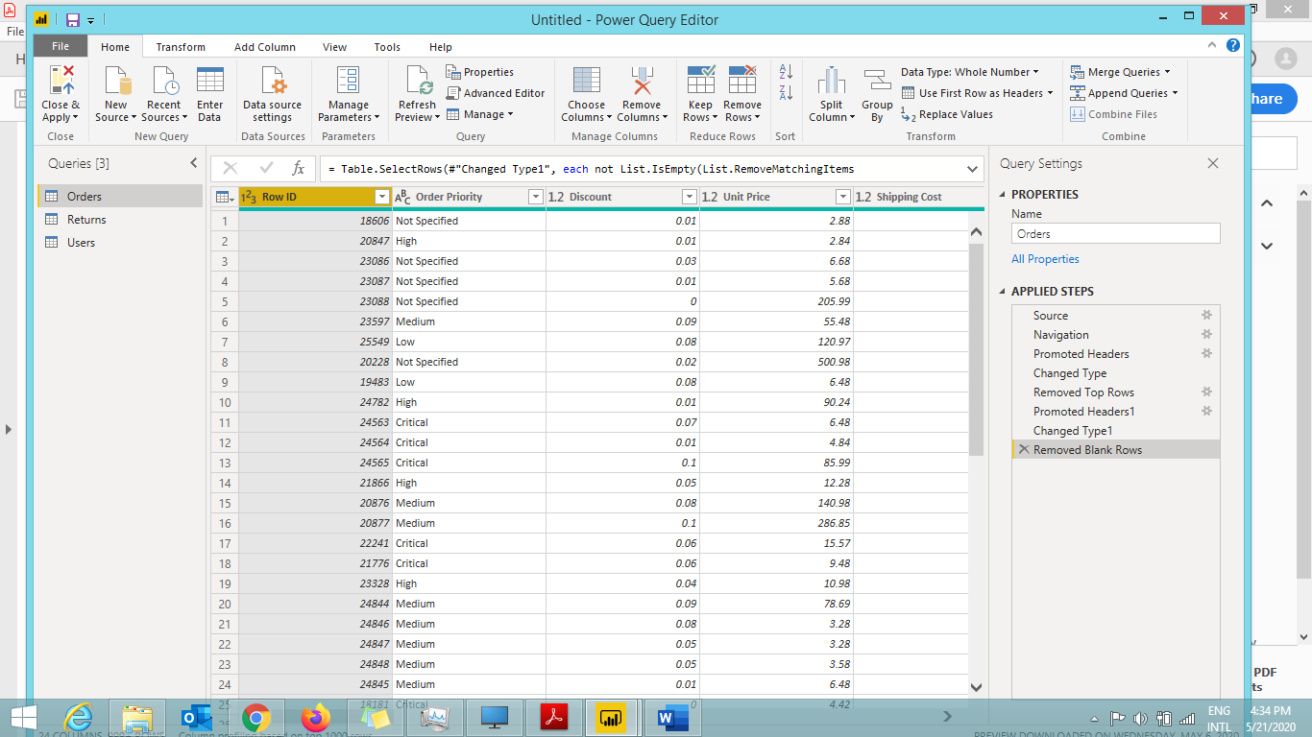

Text Table showing sales in terms of Customer, Product Category, Regions

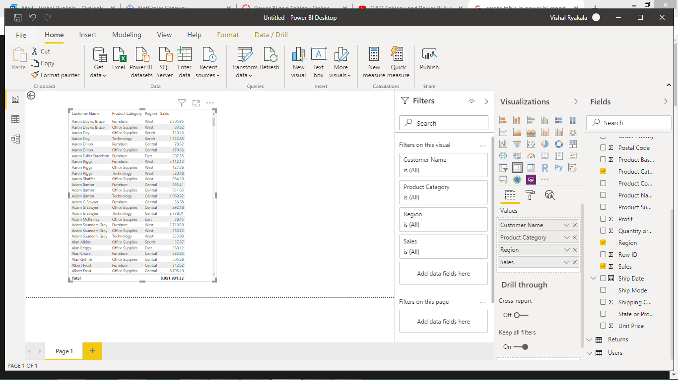

**Question-2:- Create a line and Clustered Column Chart showing the Sales and Discount as per the State or Province**

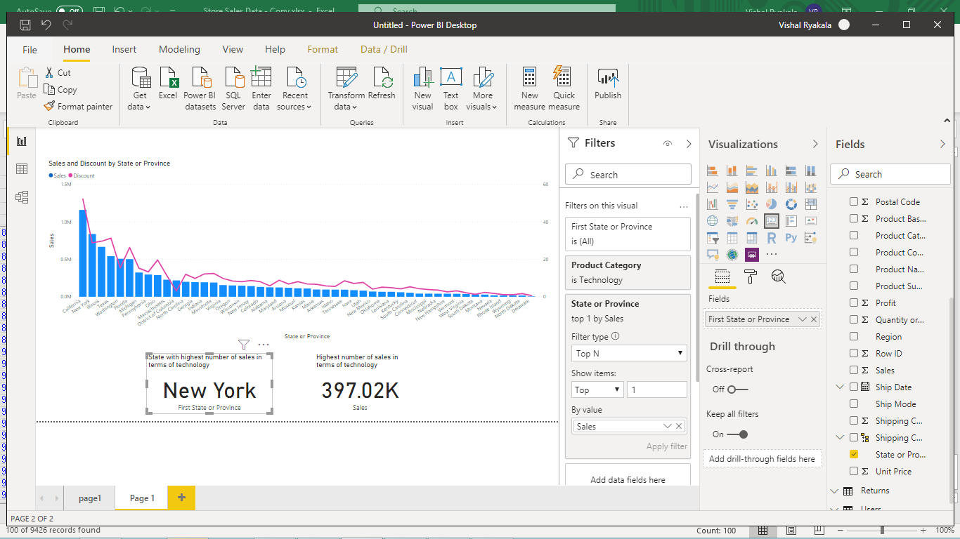

**Question-3&4:-**

* **Create a Donut Chart showing sales in terms of Product category**
* **Create a Slicer and show the regions in dropdown. See how all the visuals mentioned above behaving when a particular region is selected.**

